**Purpose:**

Road lane Detection.

**First:**

we can convert a image with three layers (R,G,B) to a image which it has just one layer ,then

implement “**Integrator Mask”** to make the edge of image softer. also you can see the result below.

* You can see how to implement a mask on the image on the link below:  
    
  <https://github.com/pardisghaziamin/Image-processing/tree/master/Implement-local-filters>

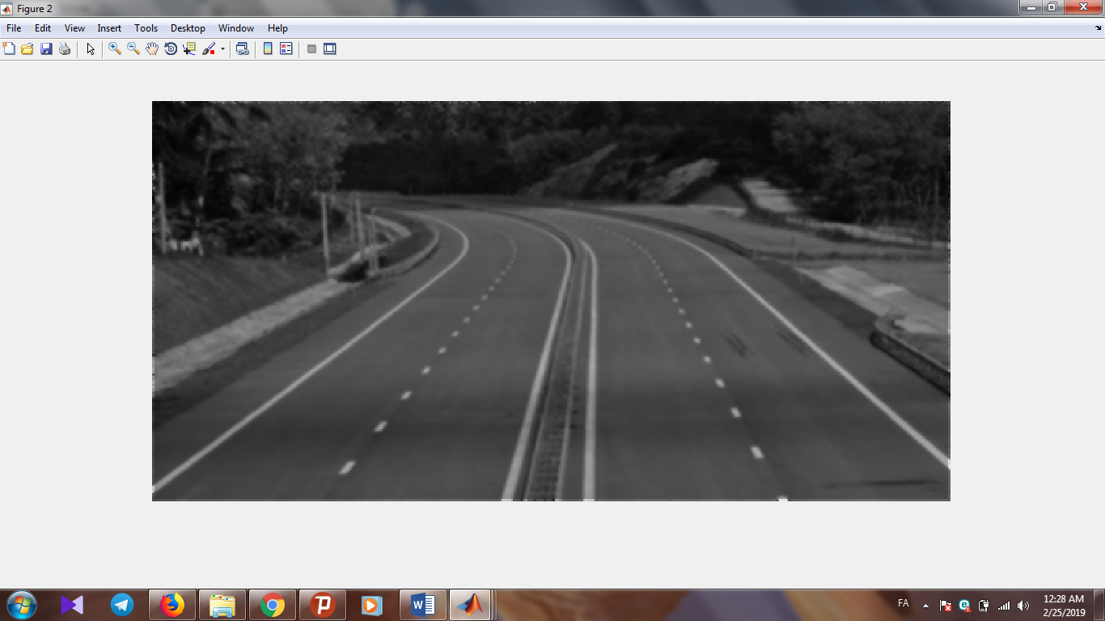

**Second:**

You can use a “**Derivative Mask**” to differentiate and separate all of the edge of the image, as you can see below:

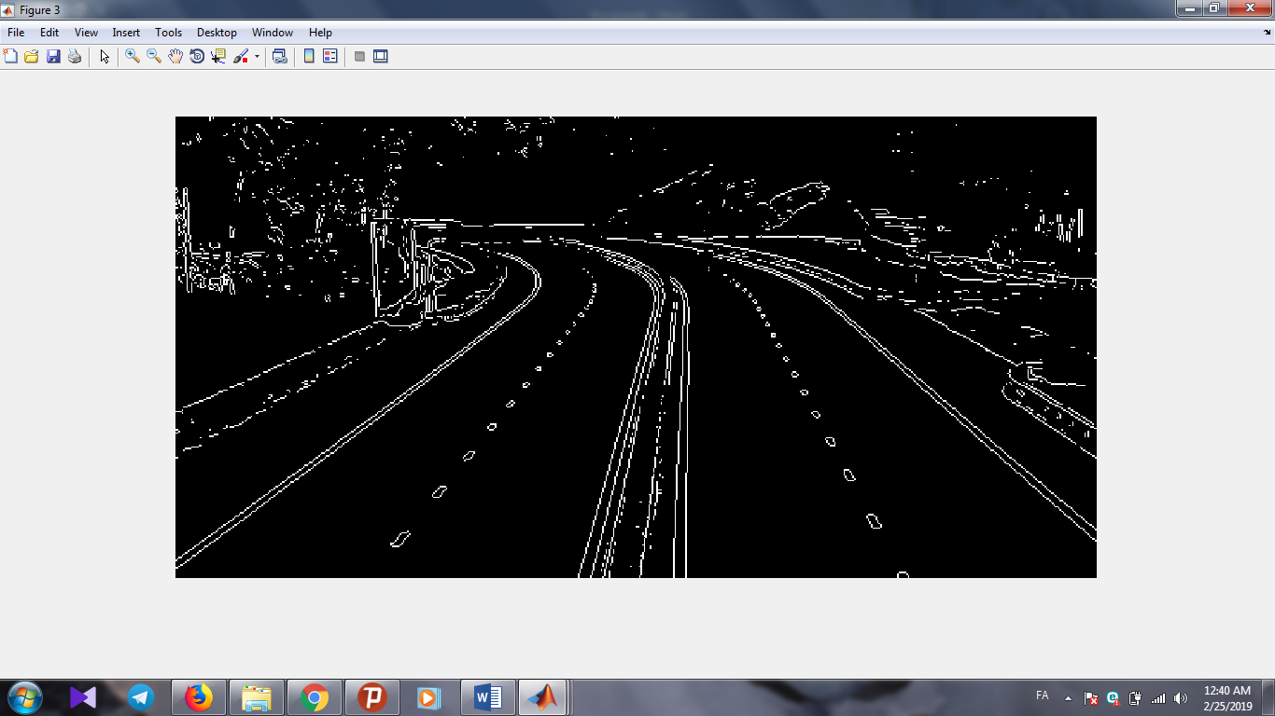

**Third:**

For detection road edge, it is better to convert image above to “**2-level**” image.

* We choose 187 between 0 to 255 as a threshold to separate the level
* Using this method help us to detect a specific edge with a specific thickness.

You can see the result below:

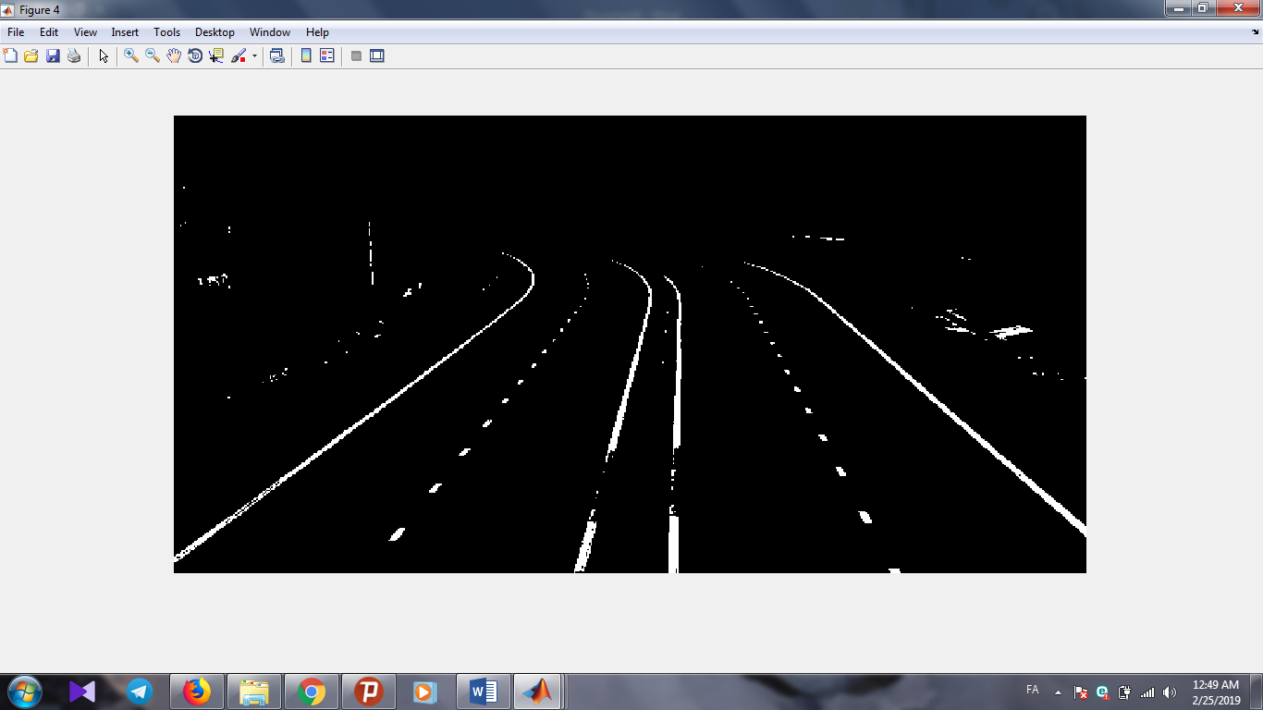

And Finally you can detect the road lane and color it such as picture below:

